High School
Half Yearly Examination
2014
Year 10
Mathematics Course
General Instructions  - Reading time: 5 minutes  - Working time: 2 hours  - There will be a short break between Section 1 and Section 2  - Write using black or blue pen  - You may use a pencil to draw or complete diagrams  - Attempt ALL questions  - Approved calculators may be used in Section 2.  - Write your Name and Teacher’s Name in the spaces provided.  - A Formula Sheet is on the reverse of this page and can be detached and used in all sections of the test. | Total Marks – 100  Section 1  Non Calculator Section.  25 marks  Time allowed for this section is 30 minutes.  Write all answers in the spaces provided.  Section 2  Time allowed for this section is 1 hour and 30 minutes.  Part A  Multiple Choice Section.  Mark your answers on the separate answer sheet at the end of the examination.  50 marks  Part B  Longer Answer Section.  Write all answers in the spaces provided.  25 marks

Formula Sheet
Pythagoras’ Theorem
c = hypotenuse
a and b are the shorter sides

Circumference of a circle
d = diameter

Area of a circle
r = radius

Area of a parallelogram
b = base
h = perpendicular height

Area of a rhombus or kite
x and y are the diagonals

Area of a trapezium
h = perpendicular height
a and b are the parallel sides

Volume of a prism
A = area of base
h = perpendicular height

Volume of a pyramid
A = area of base
h = perpendicular height

Volume of a cylinder
r = radius
h = perpendicular height

Volume of a cone

Volume of a sphere
Surface Area of a Cylinder

Surface Area of Cone
r = radius
l = slant height

Surface Area of a sphere

Trigonometric formulae for a triangle ABC.

Sine Rule

Cosine Rule
or
Area of a triangle
Simple interest
P = Principal
R = interest rate per time period as a decimal
T = number of time periods

Compound Interest
A = Final amount to which the investment grows
P = Principal
r = interest rate per compounding period as a decimal
n = number of compounding periods
Depreciation
SV = Salvage Value to which the the initial value falls
IV = Initial Value
r = depreciation rate per compounding period as a decimal
n = number of compounding periods

Gradient of a line
and are points on the line
m = gradient

Midpoint of a line segment

Length of a line segment
Equation of a line
or
b = y intercept

Half-Yearly Examination
Mathematics

Class/Teacher ______________________

Name______________________

Section 1

25 marks
Time allowed for this section is 30 minutes

Answer Questions 1–25 in the spaces provided.

Calculators are NOT to be used in this section.

There will be a short break between Section 1 and Section 2.

Section 1 Non Calculator Section
 | Write all working and answers in the spaces provided on this test paper.
1. | 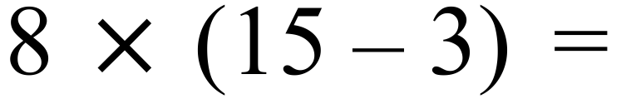  ……………………………………………………………………………………………………………  ……………………………………………………………………………………………………………
2. | 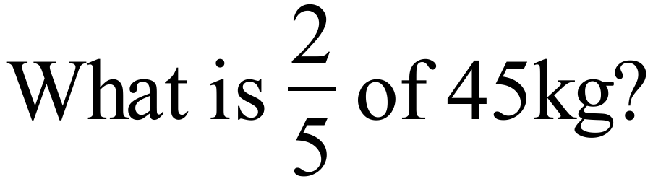  ……………………………………………………………………………………………………………  ……………………………………………………………………………………………………………
3. | 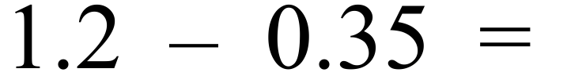  ……………………………………………………………………………………………………………  ……………………………………………………………………………………………………………
4. | Matthew is paid a commission of 6% of his sales; which are $2 400.  How much commission is he paid?  ……………………………………………………………………………………………………………  ……………………………………………………………………………………………………………
5. | Justin invests $600 in an account which pays 7% p.a. simple interest.  How much interest does he earn after 2 years?  ……………………………………………………………………………………………………………  ……………………………………………………………………………………………………………
6. | Acme Plumbing buys a trencher for $60 000 and sells it later for $45 000.  What percentage loss did they make when they sold the trencher?  ……………………………………………………………………………………………………………  ……………………………………………………………………………………………………………
7. | Simplify the ratio 4.5 kilograms : 750 grams.  ……………………………………………………………………………………………………………  ……………………………………………………………………………………………………………
8. | 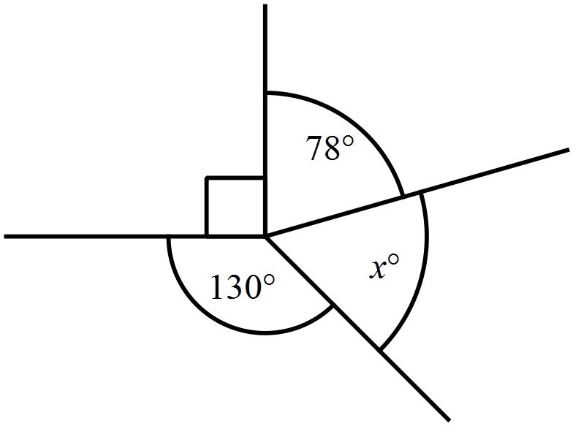What is the value of x in the diagram?  …………………………………………………  …………………………………………………  …………………………………………………  …………………………………………………
9. | What is the value of x in the diagram?  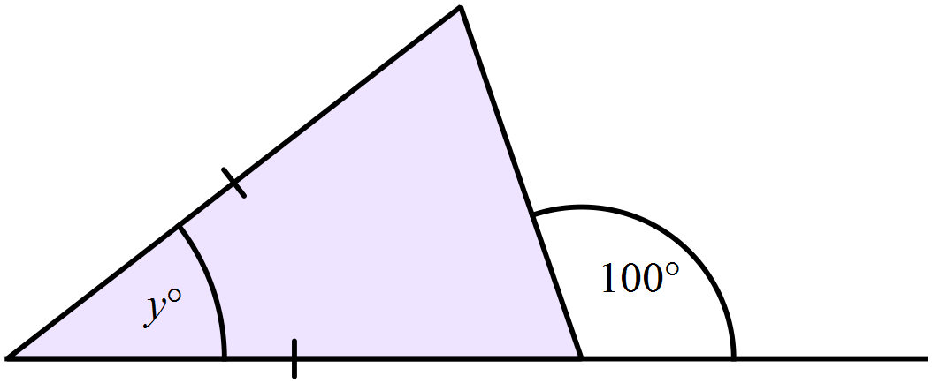…………………………………………………  …………………………………………………  …………………………………………………    …………………………………………………
10. | …………………………………………………
  Nick is looking at the properties of a particular quadrilateral. He records his observations in the table.  What name would describe the quadrilateral accurately? | Property | Yes /No
   | All sides equal | Y
   | All angles equal | N
   | Diagonals are equal | N
   | Diagonals intersect at right angles | Y
   | Axes of symmetry | Y (2)
11. | A can of cola holds 375 ml.  How many litres would a pack of 10 cans hold?  …………………………………………………………………………  …………………………………………………………………………  …………………………………………………………………………  …………………………………………………………………………
12. | 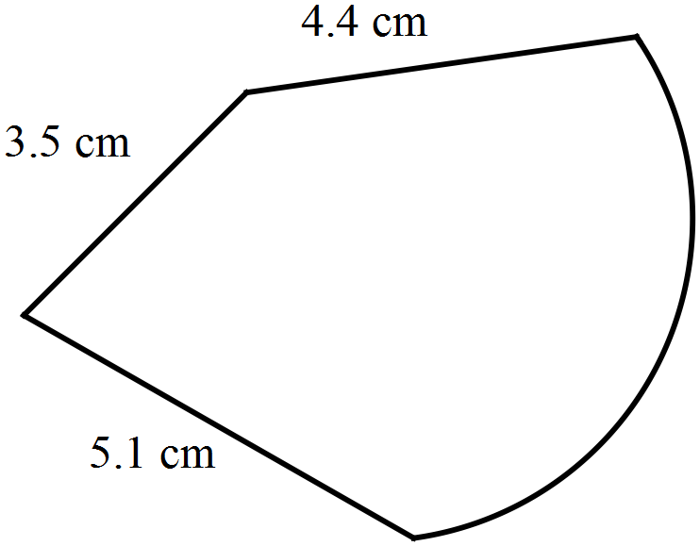The perimeter of the shape shown is 20.4 cm.  What is the length of the curved part?  ………………………………………………  …………………………………………………  …………………………………………………  …………………………………………………
13. | Find the area of the quadrilateral below.  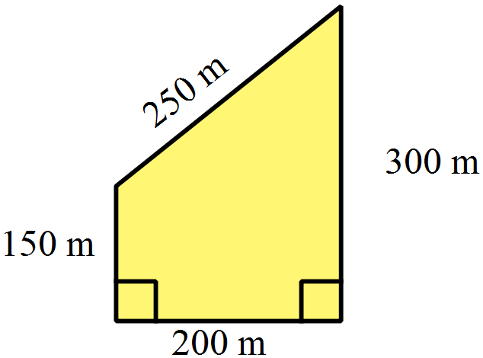  …………………………………………………  …………………………………………………  …………………………………………………  …………………………………………………
14. | 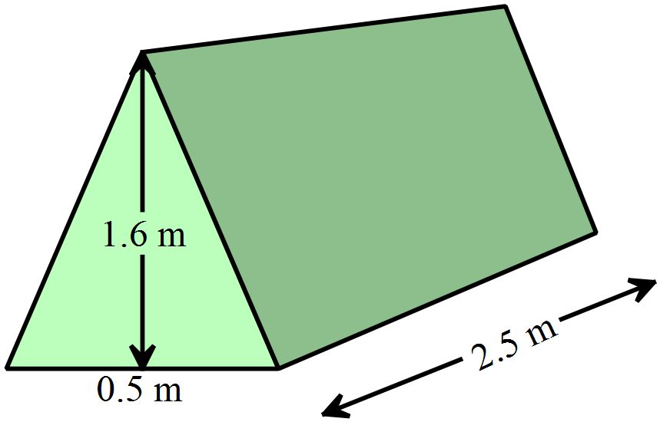What is the volume of the triangular prism below?  ………………………………………………  ………………………………………………  ………………………………………………  ………………………………………………
15. | What is the length of MN in the triangle LMN?  Leave your answer as a surd.  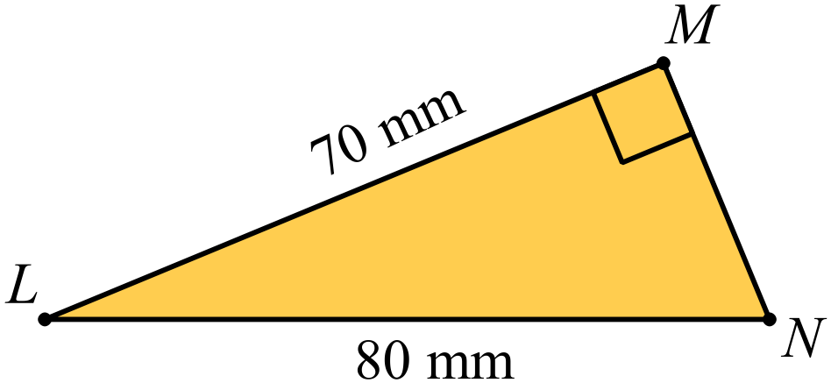  …………………………………………………  …………………………………………………  …………………………………………………  …………………………………………………
16. | Simplify 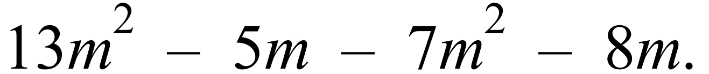  ……………………………………………………………………………………………………………
17. | 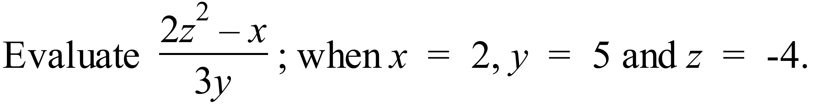  ……………………………………………………………………………………………………………  ……………………………………………………………………………………………………………
18. | Expand and simplify  ……………………………………………………………………………………………………………  ……………………………………………………………………………………………………………
19. | 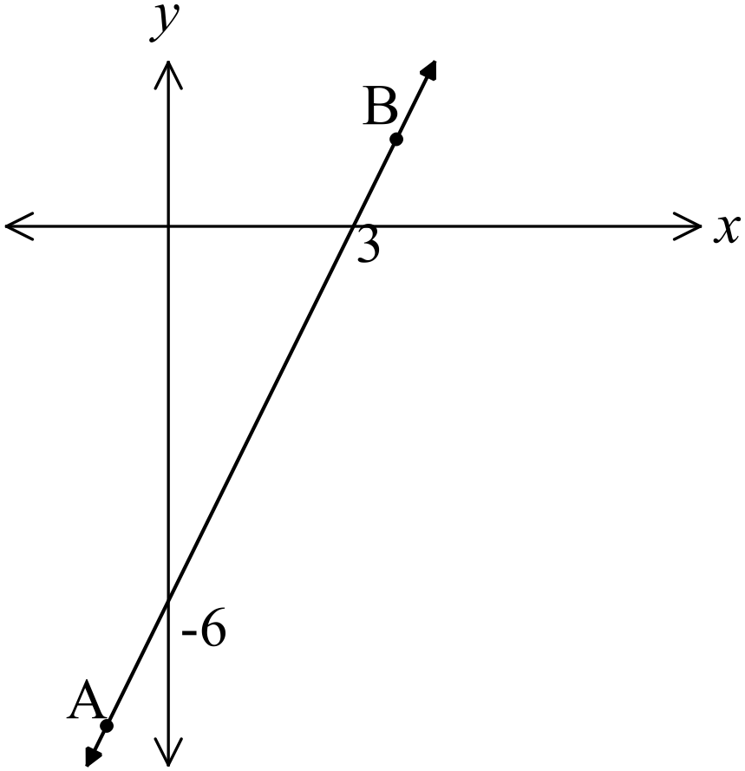What is the gradient of the line AB?  ………………………………………………  ………………………………………………  ………………………………………………  ………………………………………………
20. | Evaluate 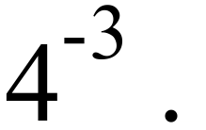  ……………………………………………………………………………………………………………
21. | Solve 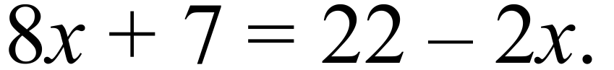  ……………………………………………………………………………………………………………  ……………………………………………………………………………………………………………
22. | 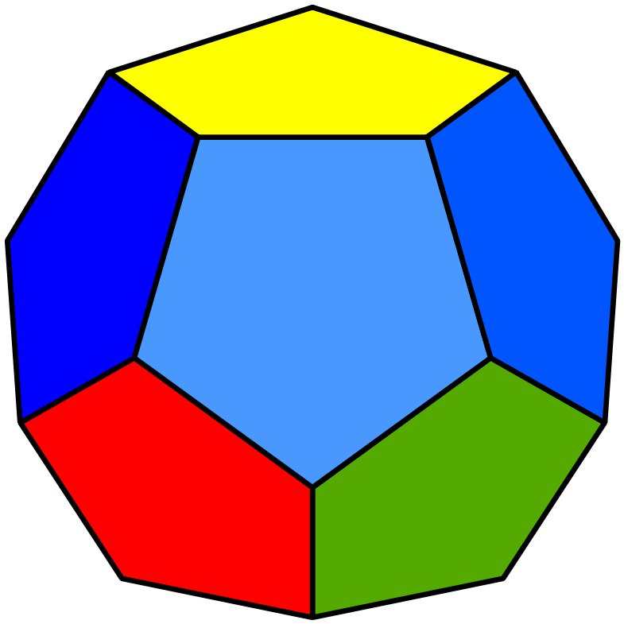A 12 sided die has 2 faces coloured yellow, 2 green, 5 blue and the remainder red.  What is the probability that a red side finishes facing up?  ………………………………………………………………  ………………………………………………………………
Questions 23 and 24 refer to the sector graph below.
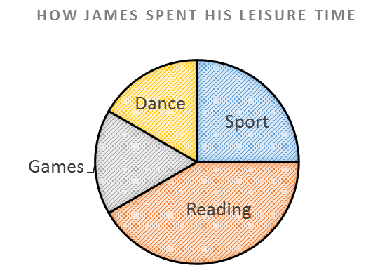

23. | Which activities took up 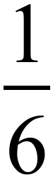 of his leisure time?  ……………………………………………………………………………………………………………  ……………………………………………………………………………………………………………
24. | James spent 6 hours a week playing sport.  How many hours did he spend reading?  ……………………………………………………………………………………………………………  ……………………………………………………………………………………………………………
25. | The dot plot shows the hours spent volunteering in a week by a group of friends.  What was the median number of hours spent volunteering?  ……………………………………………………………………………………………………………  ……………………………………………………………………………………………………………
   |  |  | O
  O |  | O | O
  O |  | O | O | O
  O | O | O | O | O
  O | O | O | O | O | O |  |  | O
  0 | 1 | 2 | 3 | 4 | 5 | 6 | 7 | 8
 | End of Section 1

Half - Yearly Examination
Mathematics

Section 2

75 marks
Time allowed for this section is
1 hour and 30 minutes

This section has TWO parts

Part A – Fifty multiple-choice questions worth 1 mark each.
Mark your answers on the separate answer sheet provided at the end of the examination.
Part B – Longer answer questions worth a total of 25 marks.
Write all answers and working in the spaces provided on this examination paper.

Calculators may be used in this section.

Do not commence Section 2 until you are instructed to do so.

Use the multiple choice answer sheet at the end of the paper to record your answers.
Completely shade the bubble corresponding to the correct answer for each question.

35% =

A. 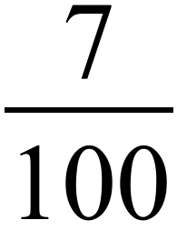 B. 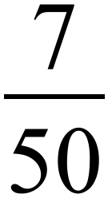 C. 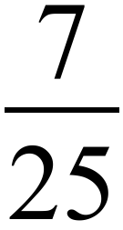 D. 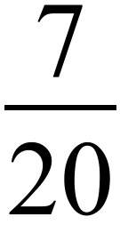

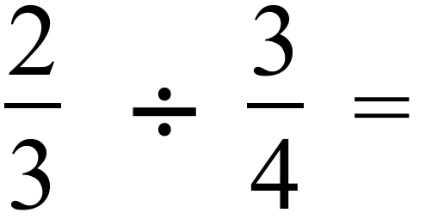

A. 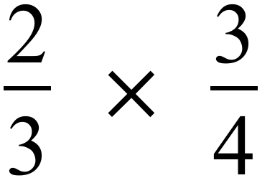 B. 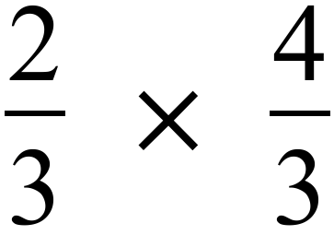 C. 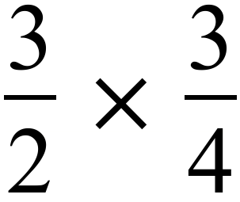 D. 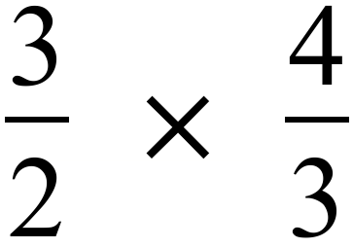

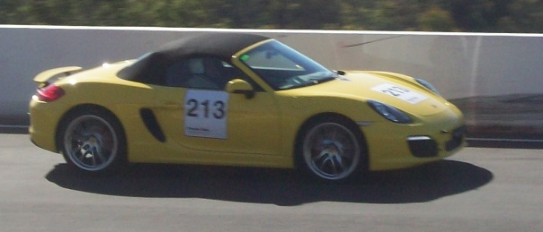
Mount Panorama racing car circuit is about 6 km long.
A car in a race averages a speed of 150 km/h.
How long would it take to complete a race which is 75 laps of the circuit?

A. 1 ½ hours B. 2 hours

C. 2 ½ hours D. 3 hours

Adam borrows $900 from a friend and pays it back after 3 years with 6% p.a. simple interest added.
How much did he repay altogether after 3 years?

A. $54 B. $162 C. $1 062 D. $1 620

Josh is paid $28 per hour for a normal forty hour week and time and a half for overtime.
What would he earn for a 48 hour week?

A. $1 344 B. $1 400 C. $1 456 D. $2 016

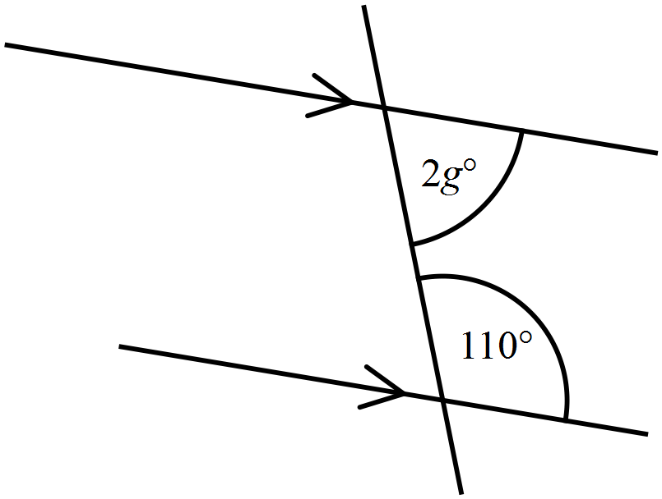What is the value of g in the diagram?

A. 30º

B. 35º

C. 55º

D. 70º

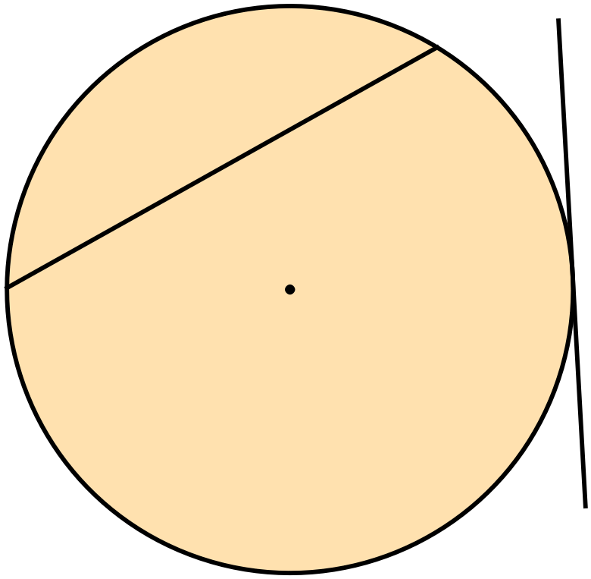What are the correct names for the two line segments drawn on the circle?

A. Diameter and Chord

B. Diameter and Tangent

C. Radius and Chord

D. Tangent and Chord

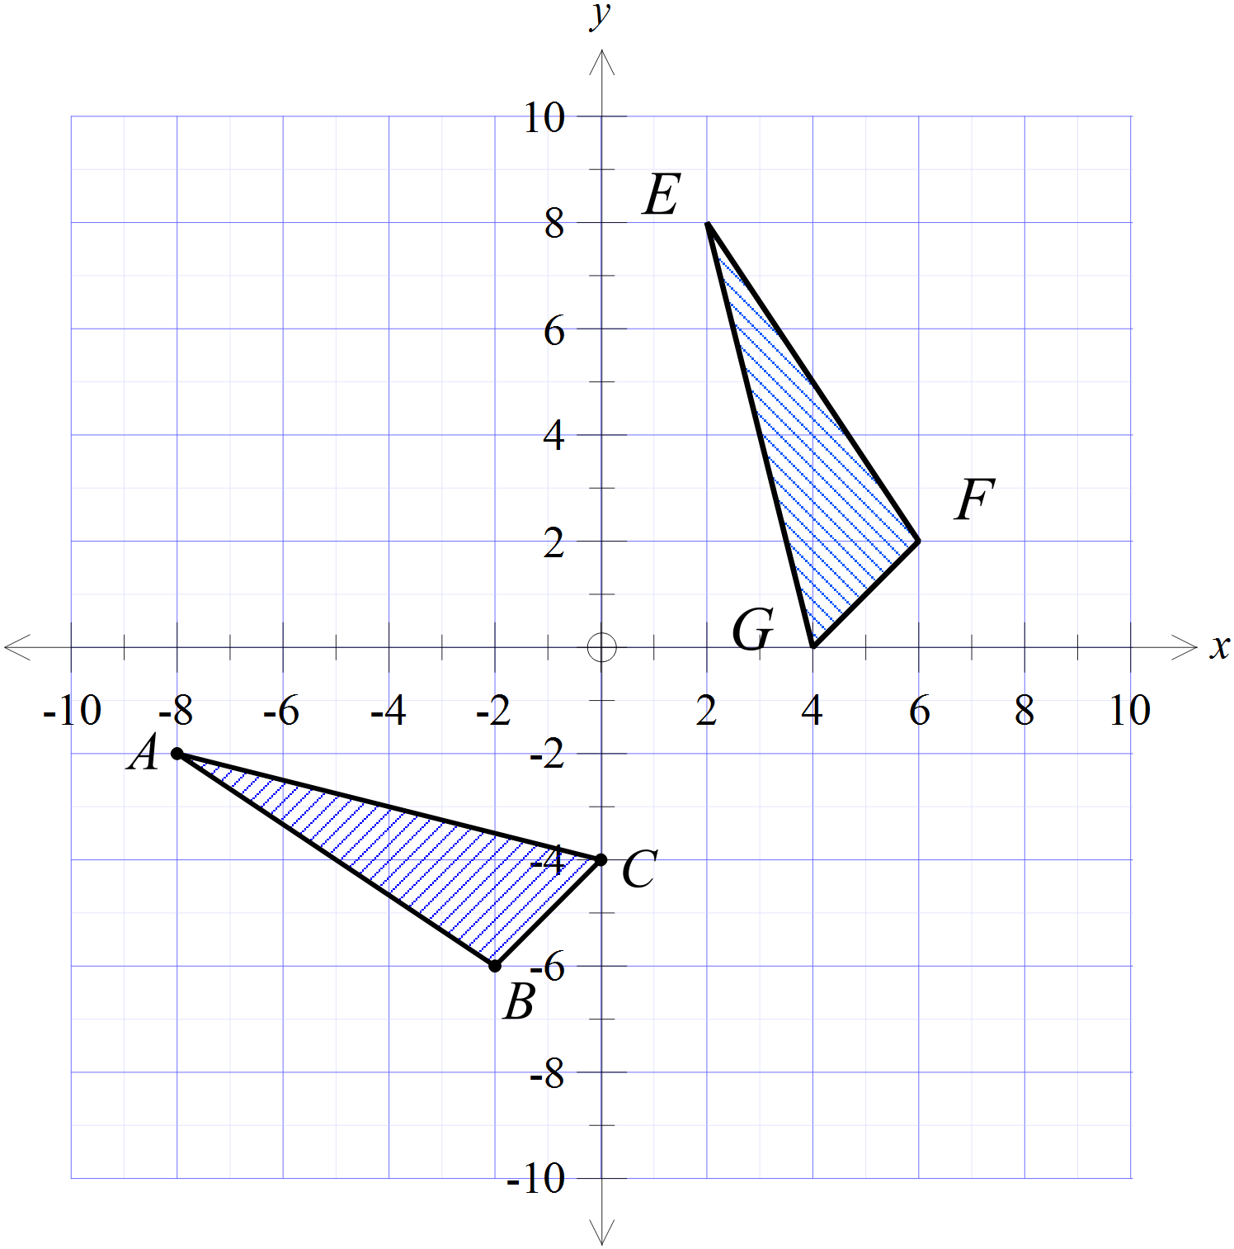Which transformation could move 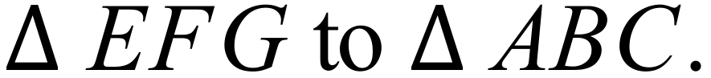

A. Reflection in the line 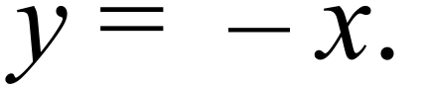

B. Reflection in the line 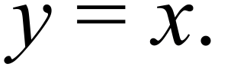

C. Rotation through 180º about the origin.

D. Translation along the line

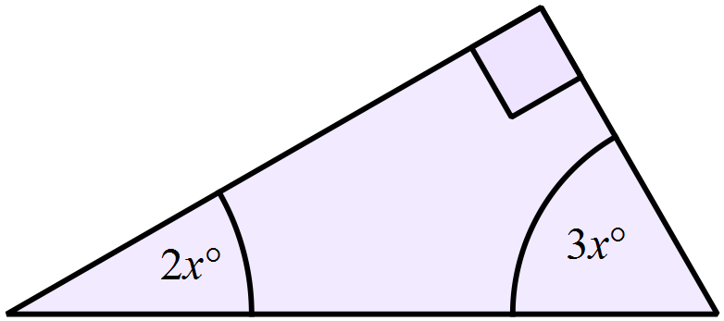What is the value of x?

A. x = 9º

B. x = 18º

C. x = 30º

D. x = 36º

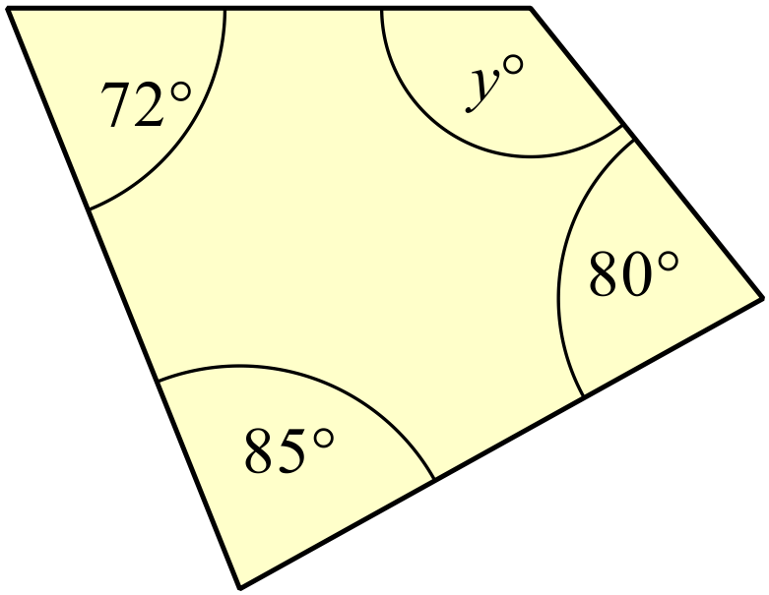What is the value of y?

A. y = 85º

B. y = 108º

C. y = 123º

D. y = 237º

The circular cricket field at Abberton Green has an area of 7 200 m².
What is it’s diameter, to the nearest metre?

A. 27 m B. 48 m C. 56 m D. 96 m

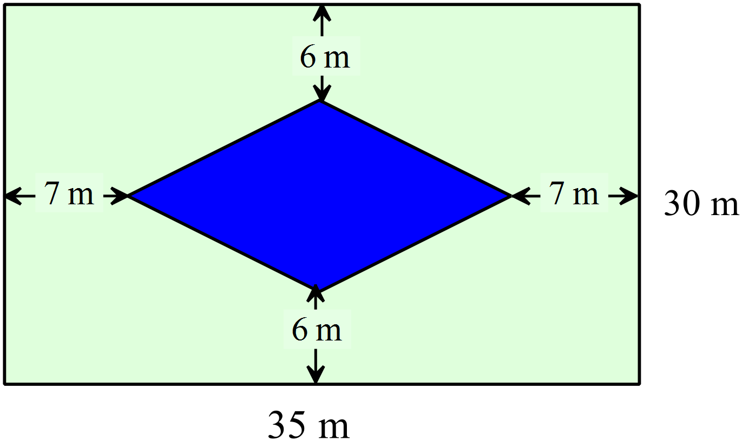A rectangular paved courtyard has a diamond shaped pond in the centre.
What is the area of the paved section?

A. 189 m²

B. 378 m²

C. 672 m²

D. 861 m²

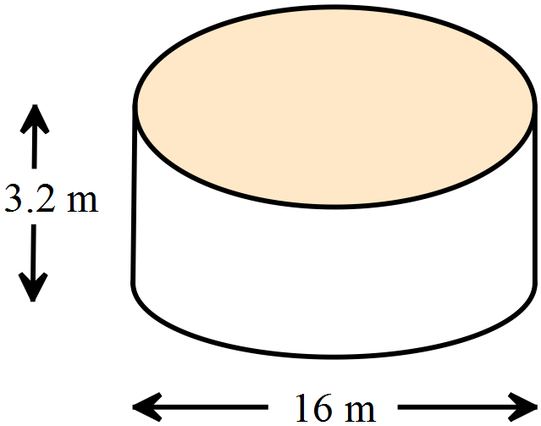What is the volume of a cylindrical tank with diameter 16 m and height 3.2 m?

A. 643 m³

B. 1 286 m³

C. 2 021 m³

D. 2 574 m³

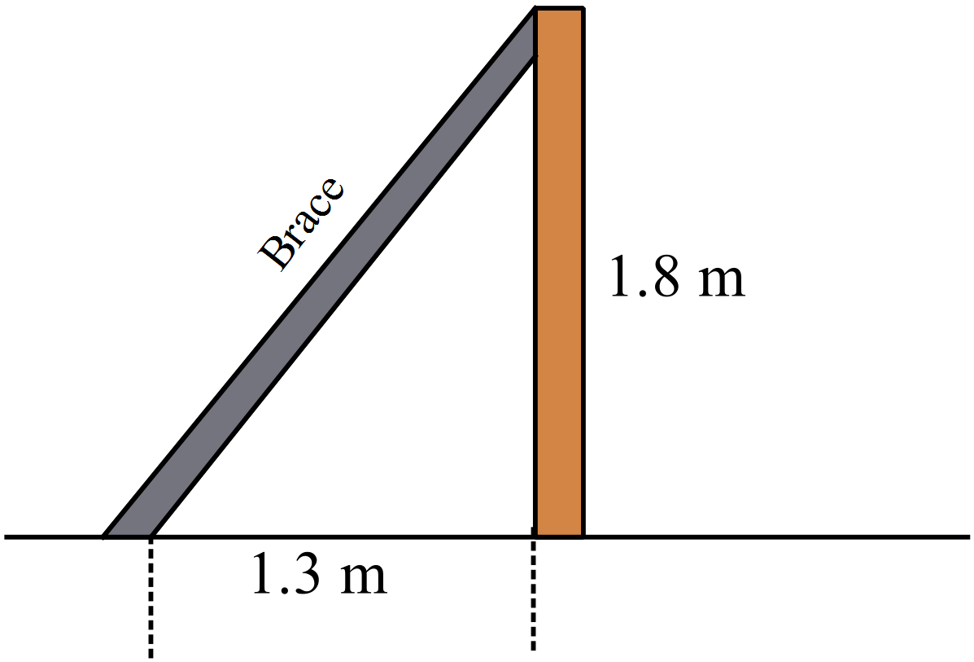A brace is attached to the top of a 1.8 m high fence to support it. The bolt on the ground to connect the brace is 1.3 m from the base of the fence.
What is the length of the brace?

A. 0.5 m

B. 1.7 m

C. 2.2 m

D. 3.1 m

What is the value of 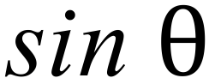 in the triangle below?
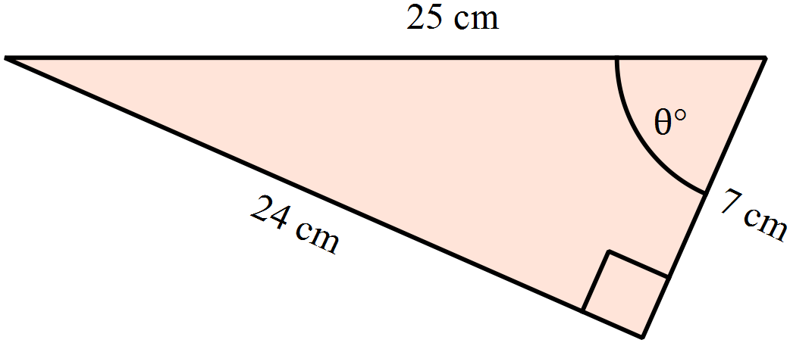

A. B. 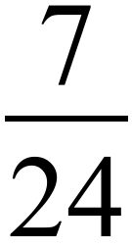

C. 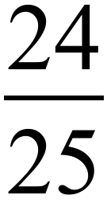 D. 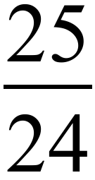

The formula for converting a temperature from degrees Fahrenheit (°F) to degrees Celsius (°C) is

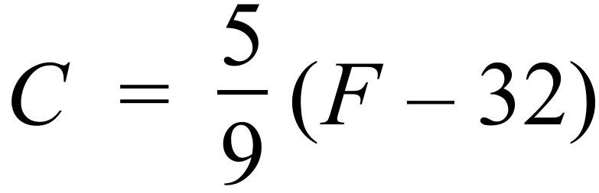

Percy receives a delivery that must be stored below 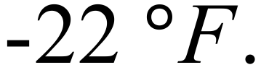
What temperature in 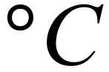 must it be stored below?

A. 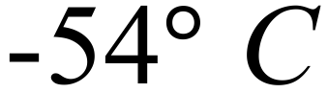 B. 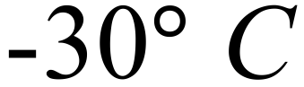 C. 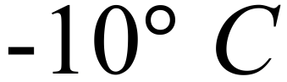 D. 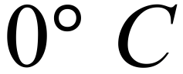

Expand and simplify 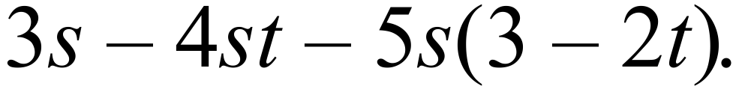

A. 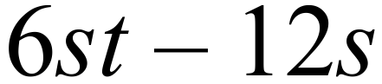 B. 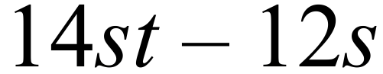 C. 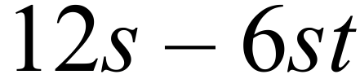 D. 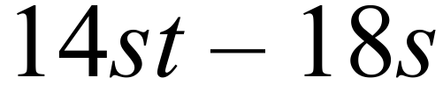

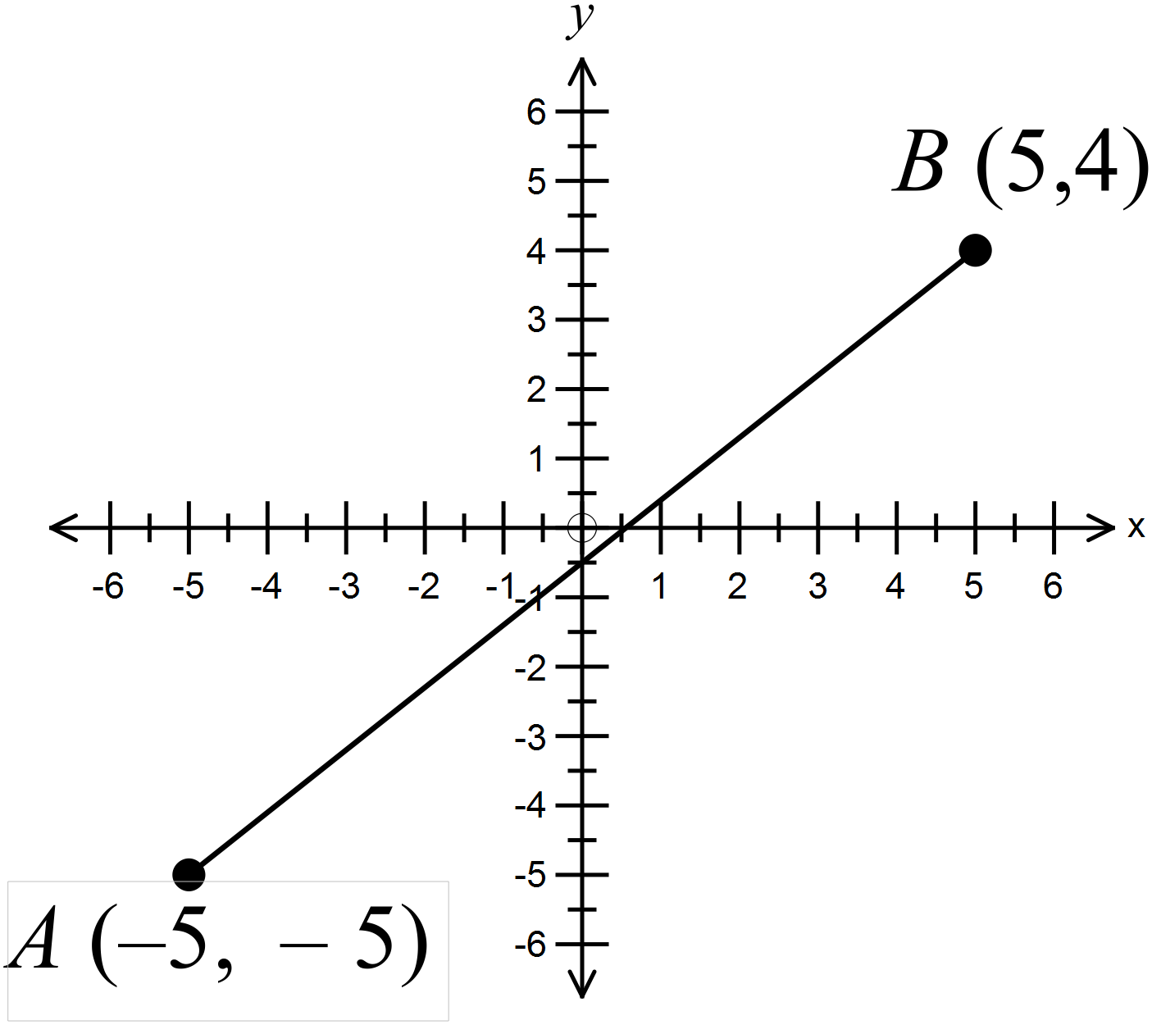What is the midpoint of the interval AB.

A. (-5, -½)

B. (0, -½)

C. (0, ½)

D. (5, ½)

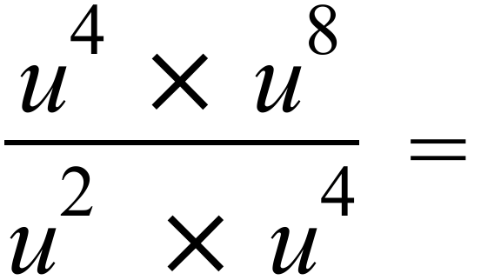

A. 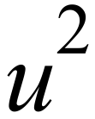 B. 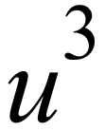 C. 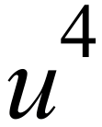 D. 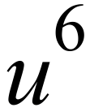

Which of the lines below could form part of the solution to this equation?

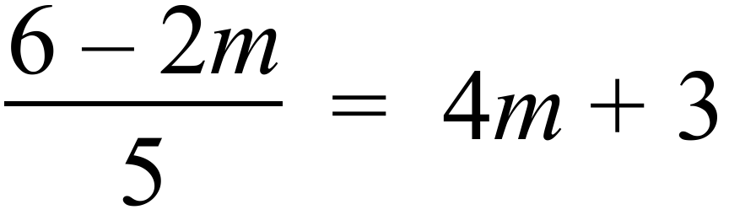

A. 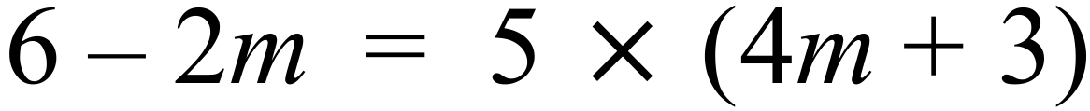

B.

C. 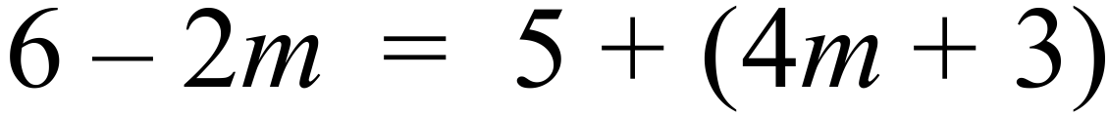

D. 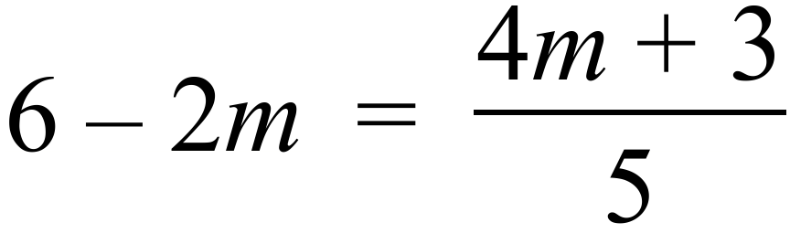

Sinead is conducting a survey as part of her PDHPE assignment.
She asks 3 males and 4 females from the 12 males and 16 females in her class to answer some questions. Her class makes up 4% of her school.

She has used:

A. A census of her class. B. A representative sample of her class.

C. A census of her school. D. A representative sample of her school.

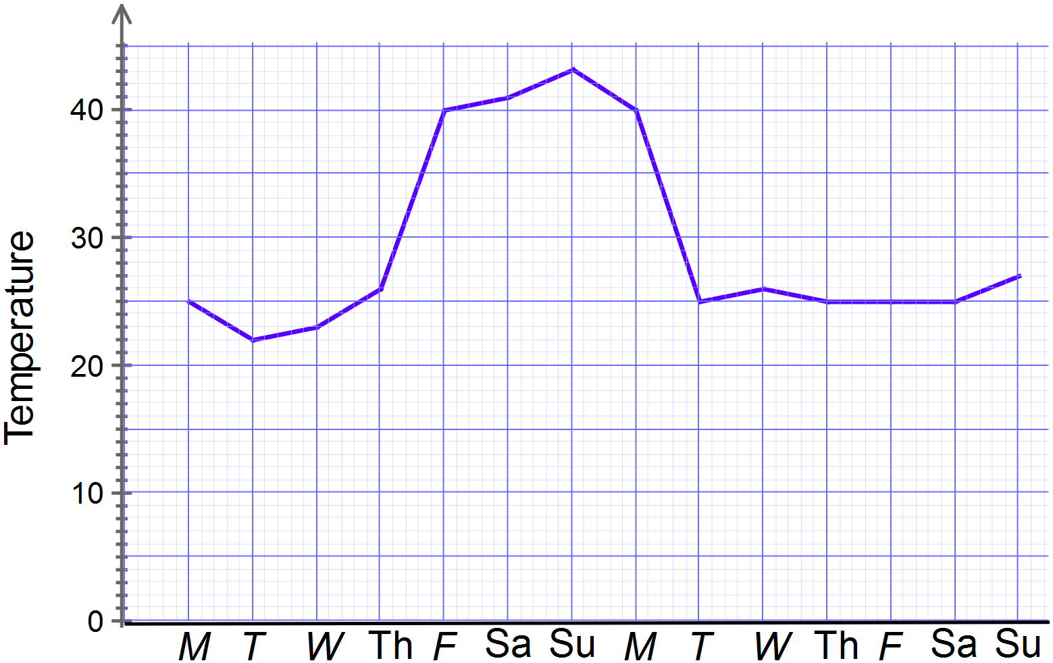Asher records the maximum daily temperature at the plant nursury where she works over a period of a fortnight.

She draws a line graph from her results.

Staff are given a bonus of $10 per day for working on days where the temperature is at or above 40º C.

How much would she have received in bonus payments in this fortnight?

A. $10 B. $20 C. $30 D. $40

Sky compiled a frequency distribution table of the number of calls per day she received from her friends on each day in April.
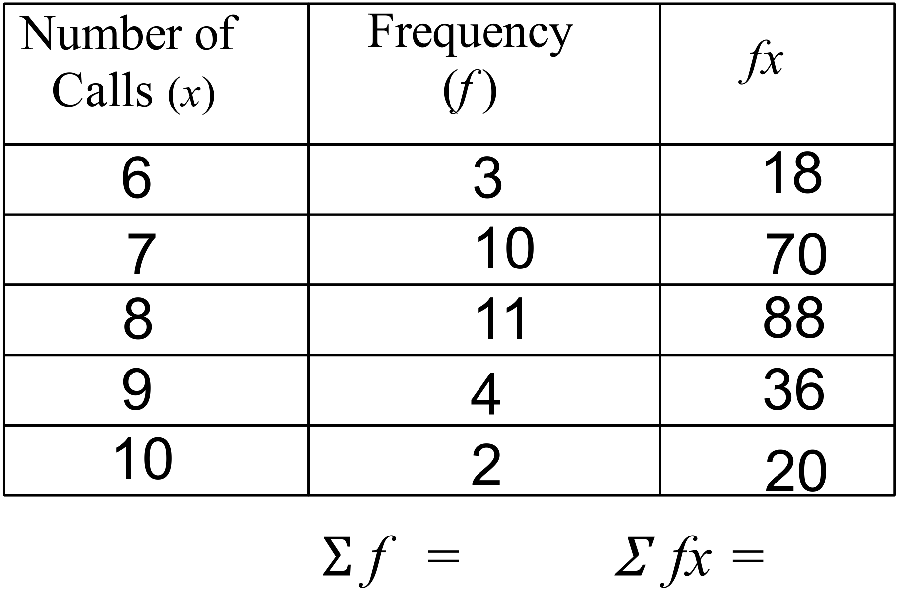

What was the mean number of calls per day (correct to one decimal place)?

A. 7.7 B. 8.0 C. 8.3 D. 8.5

Questions 49 and 50 refer to the following:
The stem and leaf plot shows the scores of 20 people on a competence test.

Stem | Leaf
6 | 7 | 9
7 | 6 | 6 | 6 | 8 | 9
8 | 2 | 5 | 5 | 6 | 6 | 8 | 9
9 | 4 | 8 | 8 | 8 | 9
10 | 0

What is/are the mode(s)?

A. 76 and 98 B. 85 and 86 C. 85.5 D. 87

What is the range of the scores?

A. 4 B. 7 C. 33 D. 40

What positive integers less than 10 could be written in the spaces marked ⌂ and □ to make the subtraction true?

 |  | 7 | 4 | 5 | –
 |  | 2 | □ | 8
 |  | 4 | 7 | ⌂

A. ⌂ = 7 and □ = 6 B. ⌂ = 6 and □ = 7

C. ⌂ = 3 and □ = 3 D. ⌂ = 7and □ = 7

Michaela invests $6 500 at 4.25% p.a. simple interest for a period of 18 months. How much interest does she earn?

A. $414.38 B. $828.75 C. $621.56 D. $4 972.50

A Notebook Computer is advertised as shown.
Notebook Computer

Cash Price - $1600
or
$342 deposit
and $70 per
month for 24 months

How much extra is paid by paying it off over 24 months, compared to the cash price?

A. $272 B. $422 C. $1 872 D. $2 022

Use the compound interest formula to find the value of a $12 000 investment earning interest at 7% p.a. compounding annually for 4 years.

A. $3 600.00 B. $3 729.55 C. $15 360.00 D. $15 729.55

When Peter won $2 500 in a lottery, he kept half and divided the rest between his sons Braiden and Trent in the ratio 3 : 2.
How much does Trent receive?

A. $500 B $750 C. $1 000 D. $1 500

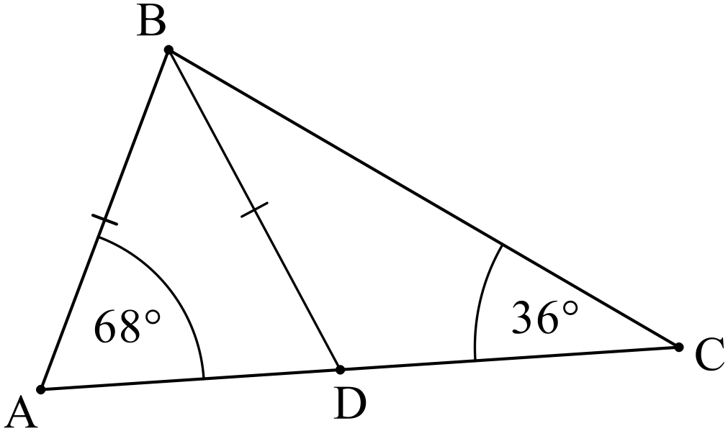What is the size of 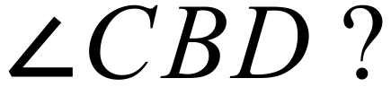

A. 32º B. 44º

C. 68º D. 76º

A parallelogram ABCD has both its diagonals drawn, intersecting at E.
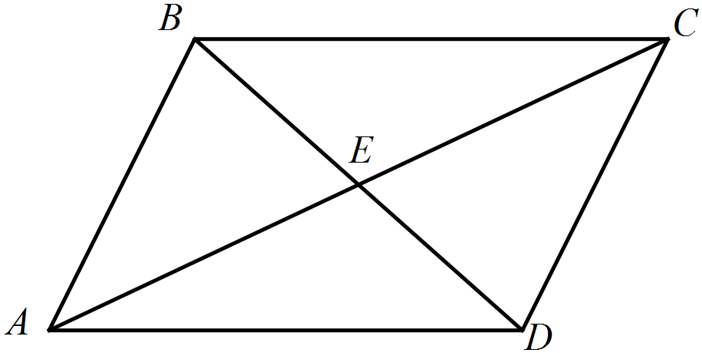
Which pair of triangles are congruent?

A. 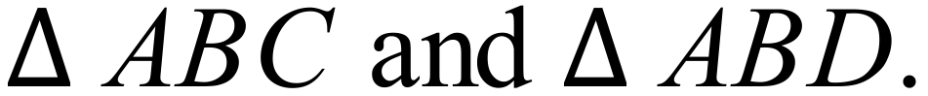

B. 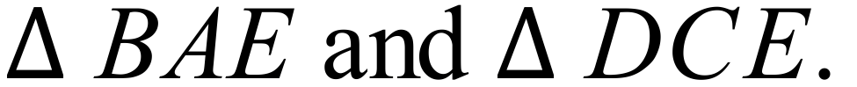

C.

D. 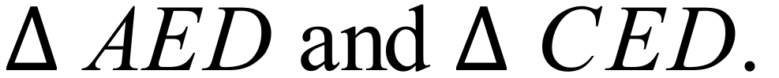

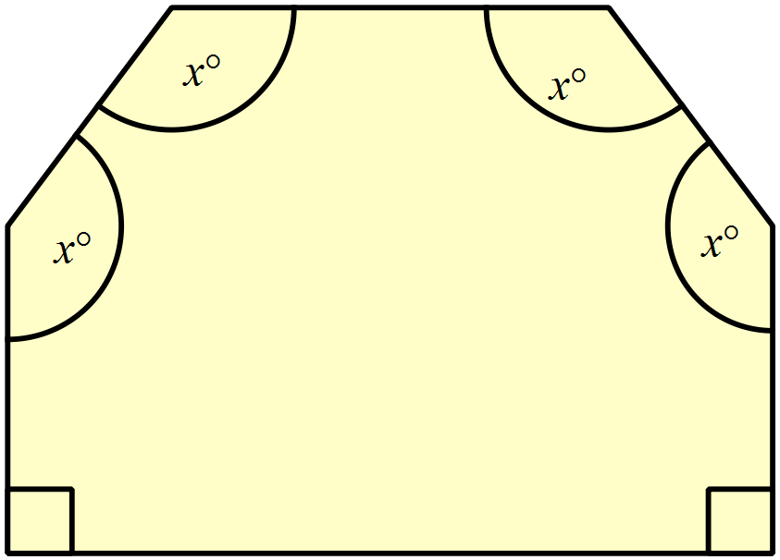There are two right angles and four angles which are equal to xº in the irregular hexagon shown.
What is the value of x?

A. 115º

B. 120º

C. 135º

D. 150º

Theo makes two statements about the figure below.

- The figure has exactly two axes of line symmetry.
- The figure has rotational symmetry of order four.

Which is true?

A. Both statements are true.

B. Neither statement is true.

C. Only statement I is true.

D. Only statement II is true.

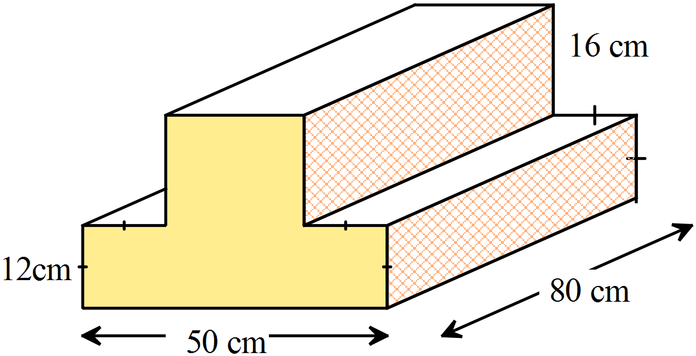Find the volume of the prism shown.

A. 1 016 cm³

B. 8 128 cm³

C. 10 160 cm³

D. 81 280 cm³

Find the surface area of the triangular prism shown.
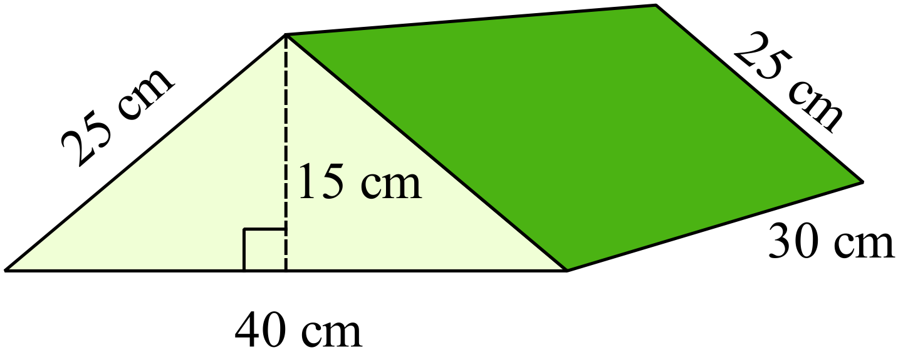
A. 2 100 m²
B. 3 000 m²
C. 3 300 m²
D. 9 000 m²

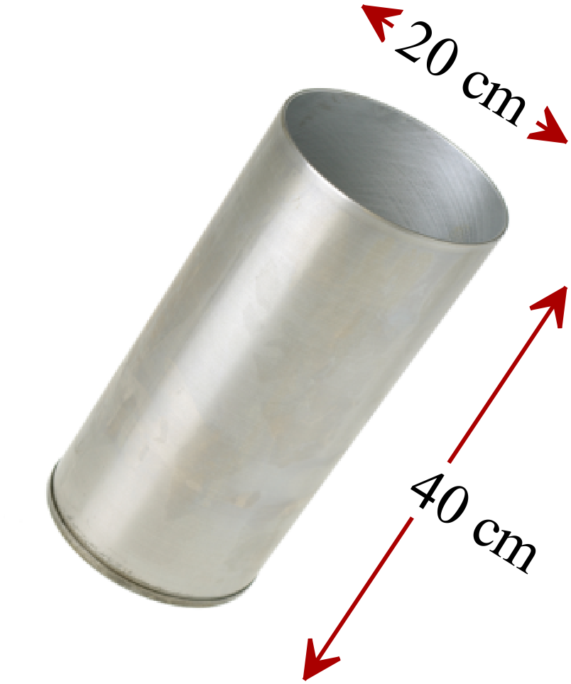A cylindrical metal container has a diameter of 20 cm and a depth of 40 cm and is open at one end.

Find the area of metal used to make the beaker.

A. 628 cm²

B. 2 512 cm²

C. 2 827 cm²

D. 3 140 cm²

If 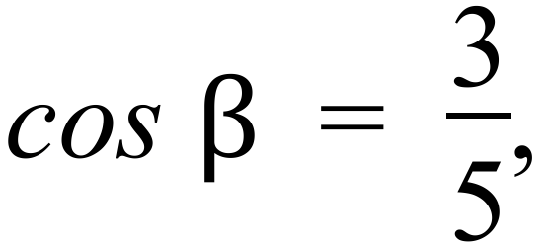 what is the size of angle 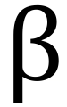 to the nearest degree?

A. 31 º B. 37 º C. 53 º D. 59º
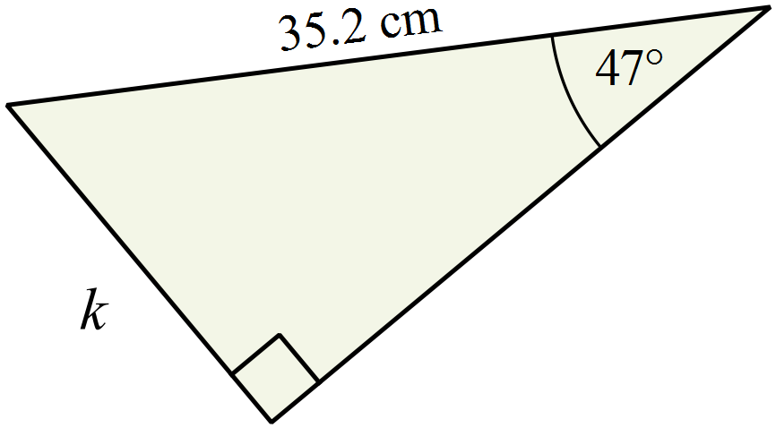Find the value of k, correct to one decimal place.

A. 25.7 cm

B. 37.7 cm

C. 47.0 cm

D. 48.1 cm
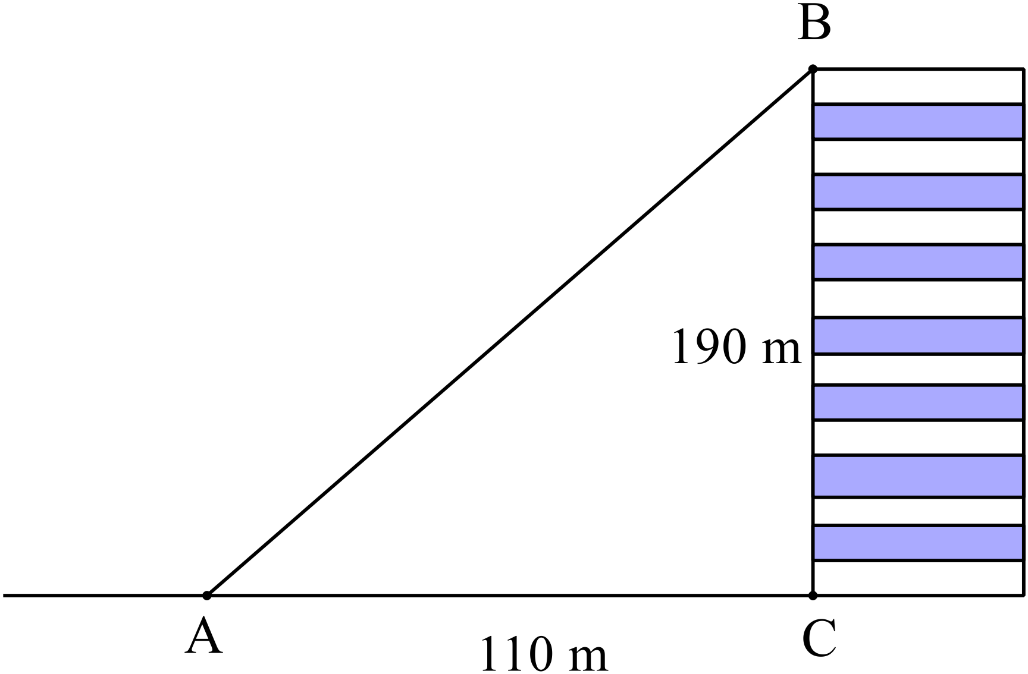What is the angle of elevation of B from A?

A. 30º

B. 60º

C. 75º

D. 85º

Which term below is not a factor of 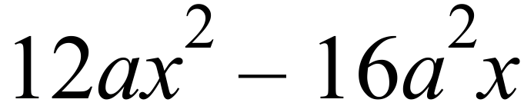

A. 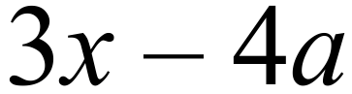 B. 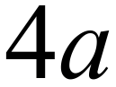 C. 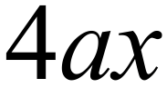 D. 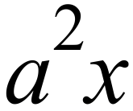

A line has a gradient of and passes through the point 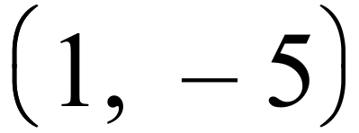 . What is its equation?

A. 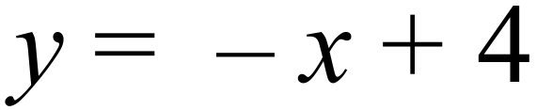

B. 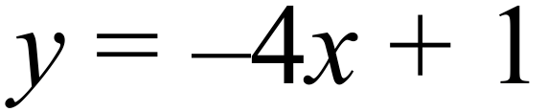

C. 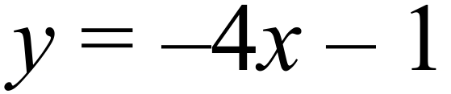

D. 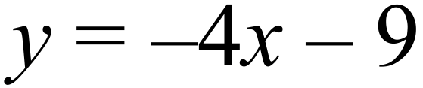

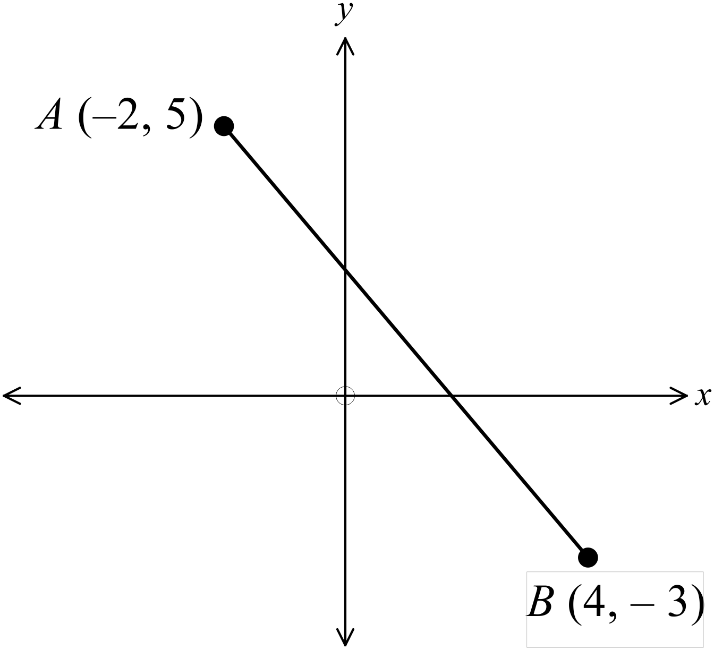What is the length of the interval AB?

A. 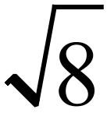 units

B. 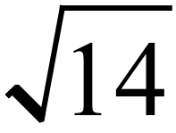 units

C. 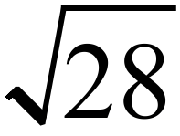 units

D. 10 units

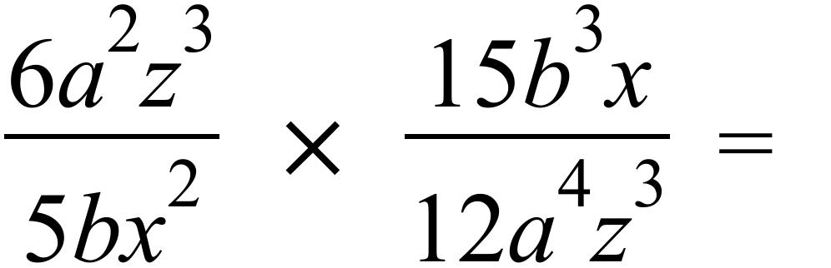

A. 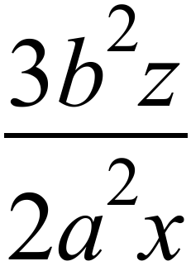 B. 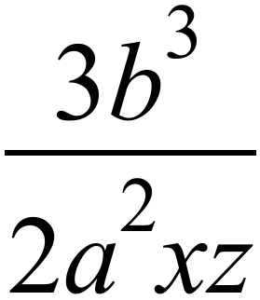 C. 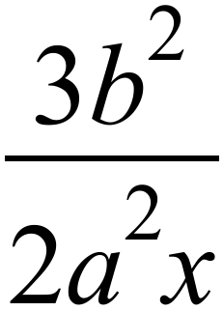 D. 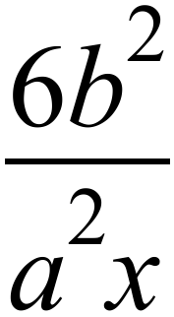

What is the solution to the equation 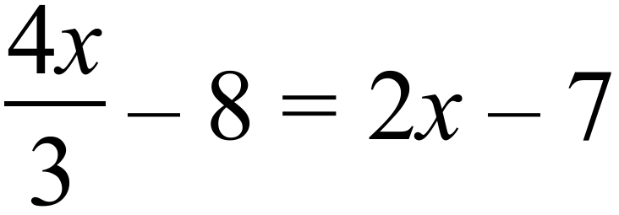 ?

A. 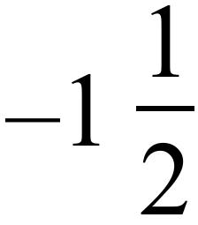 B. 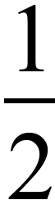 C. 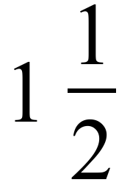 D. 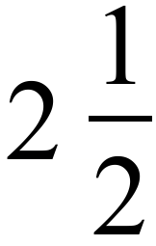

Questions 71 – 73 refer to the stem and leaf plot.

The coach of the Emattogah Cricket Club compiles the stem and leaf plot showing the ages of their players.
Ages of Emattogah Cricket Players
1 | 4 | 5 | 6 | 6 | 8 | 9
2 | 0 | 2 | 4 | 6 | 7 | 9 | 9 | 9
3 | 1 | 3 | 4 | 5 | 5 | 7
4 | 2 | 6
5 | 3

How many players are there in the club?

A. 22 B. 23 C. 24 D. 28

What is the median age of the players?

A. 27 B. 28 C. 29 D. 30

What is the upper quartile of their ages?

A. 34.5 B. 35 C. 36 D. 37

Questions 74 – 75 refer to the following dot plot.
Frequency
Frequency |  | O |  |  |  |  |  | O
Frequency |  | O |  |  |  |  |  | O
Frequency |  | O | O |  |  |  | O | O
Frequency | O | O | O | O |  | O | O | O | O
Frequency | O | O | O | O | O | O | O | O | O
Frequency | 1 | 2 | 3 | 4 | 5 | 6 | 7 | 8 | 9
Frequency | Score

Which two terms could be applied to describe the distribution?

A. Bimodal and Skewed

B. Bimodal and Symmetrical

C. Unimodal and Skewed

D. Unimodal and Symmetrical

Which would be true of the distribution.

A. The mean and mode would be equal.

B. The mean and range would be equal.

C. The mean and median would be equal.

D. The median and mode would be equal.

Section 2  Part B  Longer Answer Section |  | Name : _______________________________
 |  | Class/Teacher___________________________
Questions 76 – 83 25 marks in total
The marks awarded are shown beside the question.
Write all working and answers in the spaces provided on this examination paper.
Calculators are allowed for this section.

 |  | Marks
76. | The table below gives the value of $1.00 after being invested at different rates of compound interest for varying terms.
   | Compound interest rate pa
  Years  Invested | 2% | 3% | 4% | 5% | 6% | 7% | 8%
  1 | $1.0200 | $1.0300 | $1.0400 | $1.0500 | $1.0600 | $1.0700 | $1.0800
  2 | $1.0404 | $1.0609 | $1.0816 | $1.1025 | $1.1236 | $1.1449 | $1.1664
  3 | $1.0612 | $1.0927 | $1.1249 | $1.1576 | $1.1910 | $1.2250 | $1.2597
  4 | $1.0824 | $1.1255 | $1.1699 | $1.2155 | $1.2625 | $1.3108 | $1.3605
  5 | $1.1041 | $1.1593 | $1.2167 | $1.2763 | $1.3382 | $1.4026 | $1.4693
  6 | $1.1262 | $1.1941 | $1.2653 | $1.3401 | $1.4185 | $1.5007 | $1.5869
  7 | $1.1487 | $1.2299 | $1.3159 | $1.4071 | $1.5036 | $1.6058 | $1.7138
  8 | $1.1717 | $1.2668 | $1.3686 | $1.4775 | $1.5938 | $1.7182 | $1.8509
 | - What would be the value of an investment of $7 500.00 after 6 years invested at 8% p.a. compound interest?  ..................................................................................................................................................  .................................................................................................................................................. | 1
 | - What interest rate would you need for an investment of $8 000.00 to grow to $10 100 after 4 years?  ..................................................................................................................................................  .................................................................................................................................................. | 1
 | - Use the compound interest formula to find the how much extra would be earned by allowing the investment in part a) to continue for a further four years. (i.e. ten years in total).  ………......................................................................................................................................  ………...................................................................................................................................... | 1
77. | 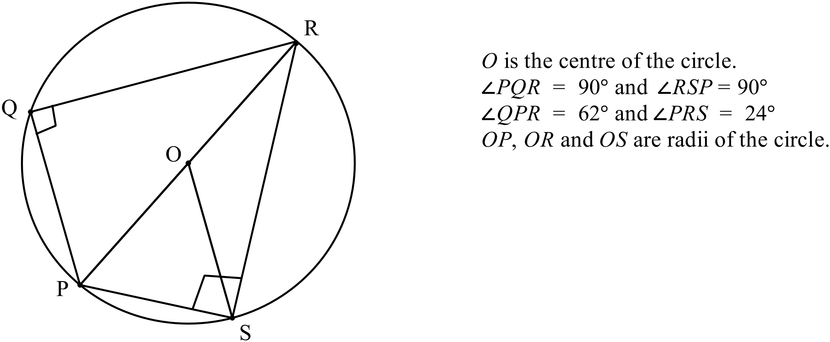  ………………………………………………………………………………………………  ………………………………………………………………………………………………  ………………………………………………………………………………………………  ……………………………………………………………………………………………… | 3
78. | 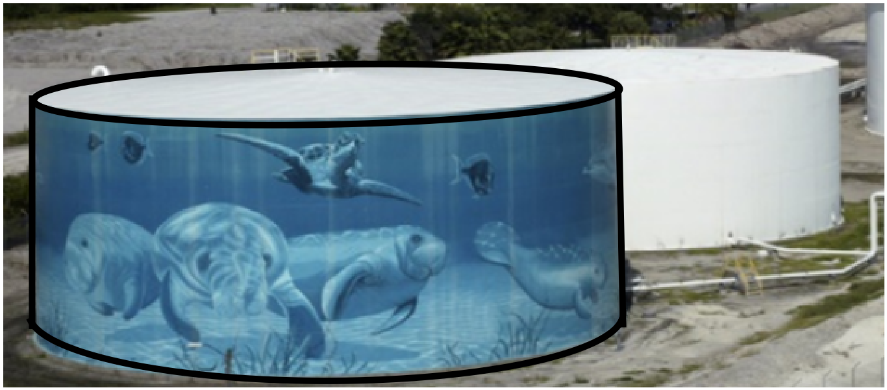A large cylindrical tank to hold petroleum is to be painted with a mural, similar to that shown.  The tank has a diameter of 30 metres and a height of 10 metres.
 | - Only the curved surface of the tank is to be painted with a paint that covers 25 m² per litre.  How many litres of paint would be needed?  ………………………………………………………………………………………………  ……………………………………………………………………………………………… | 2
 | - How many litres of petroleum would be held in the tank (to the nearest 1 000 litres) ?  1 m³ holds 1 kilolitre.  ………………………………………………………………………………………………  ……………………………………………………………………………………………… | 1
79. | Four friends Leo (L), Mark (M), Nicole (N) and Olivia (O) are standing in an open flat field as shown.  Nicole is due south of Leo.  Olivia, Leo and Mark are standing in a straight line which runs East-West.  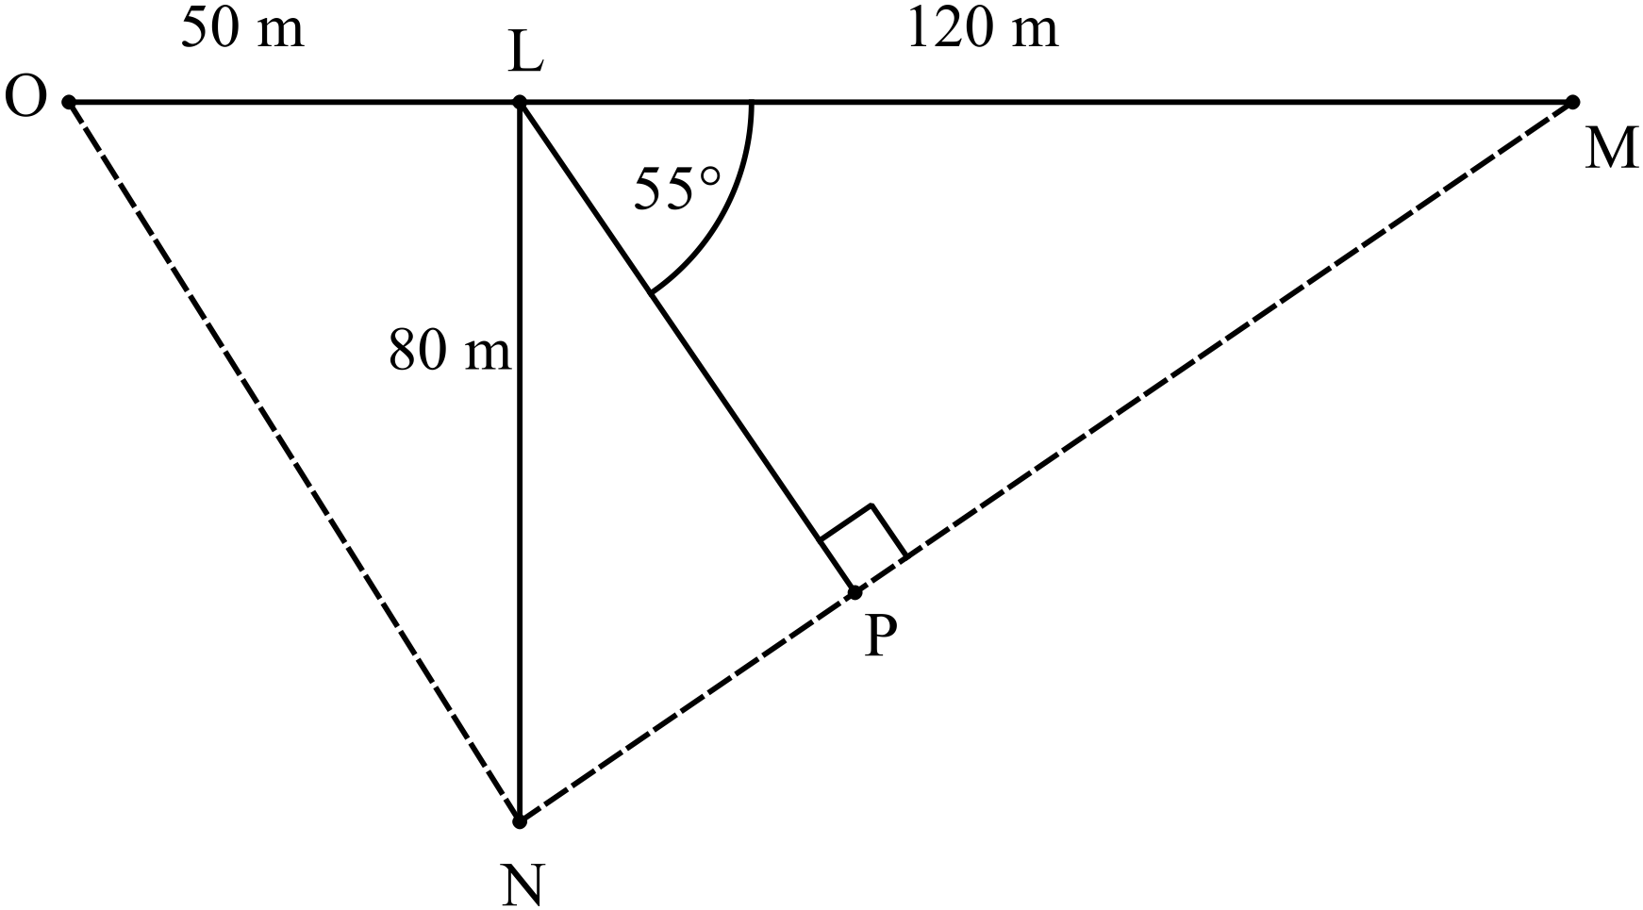
 | - How far is Nicole from Olivia (to the nearest metre)?  ……………………………………………………………………………………………….  ………………………………………………………………………………………………. | 1
 | - Find the angle LON and hence give the bearing of Nicole from Olivia?  Answer to the nearest degree.  ……………………………………………………………………………………………….  ………………………………………………………………………………………………. | 2
 | - Peter (P) places himself on the line between Nicole and Mark; so that the angle PLM is 55º and angle LPM = 90º  How far is Peter from Mark?  Answer to the nearest metre.  ……………………………………………………………………………………………….  ………………………………………………………………………………………………. | 1
80. | 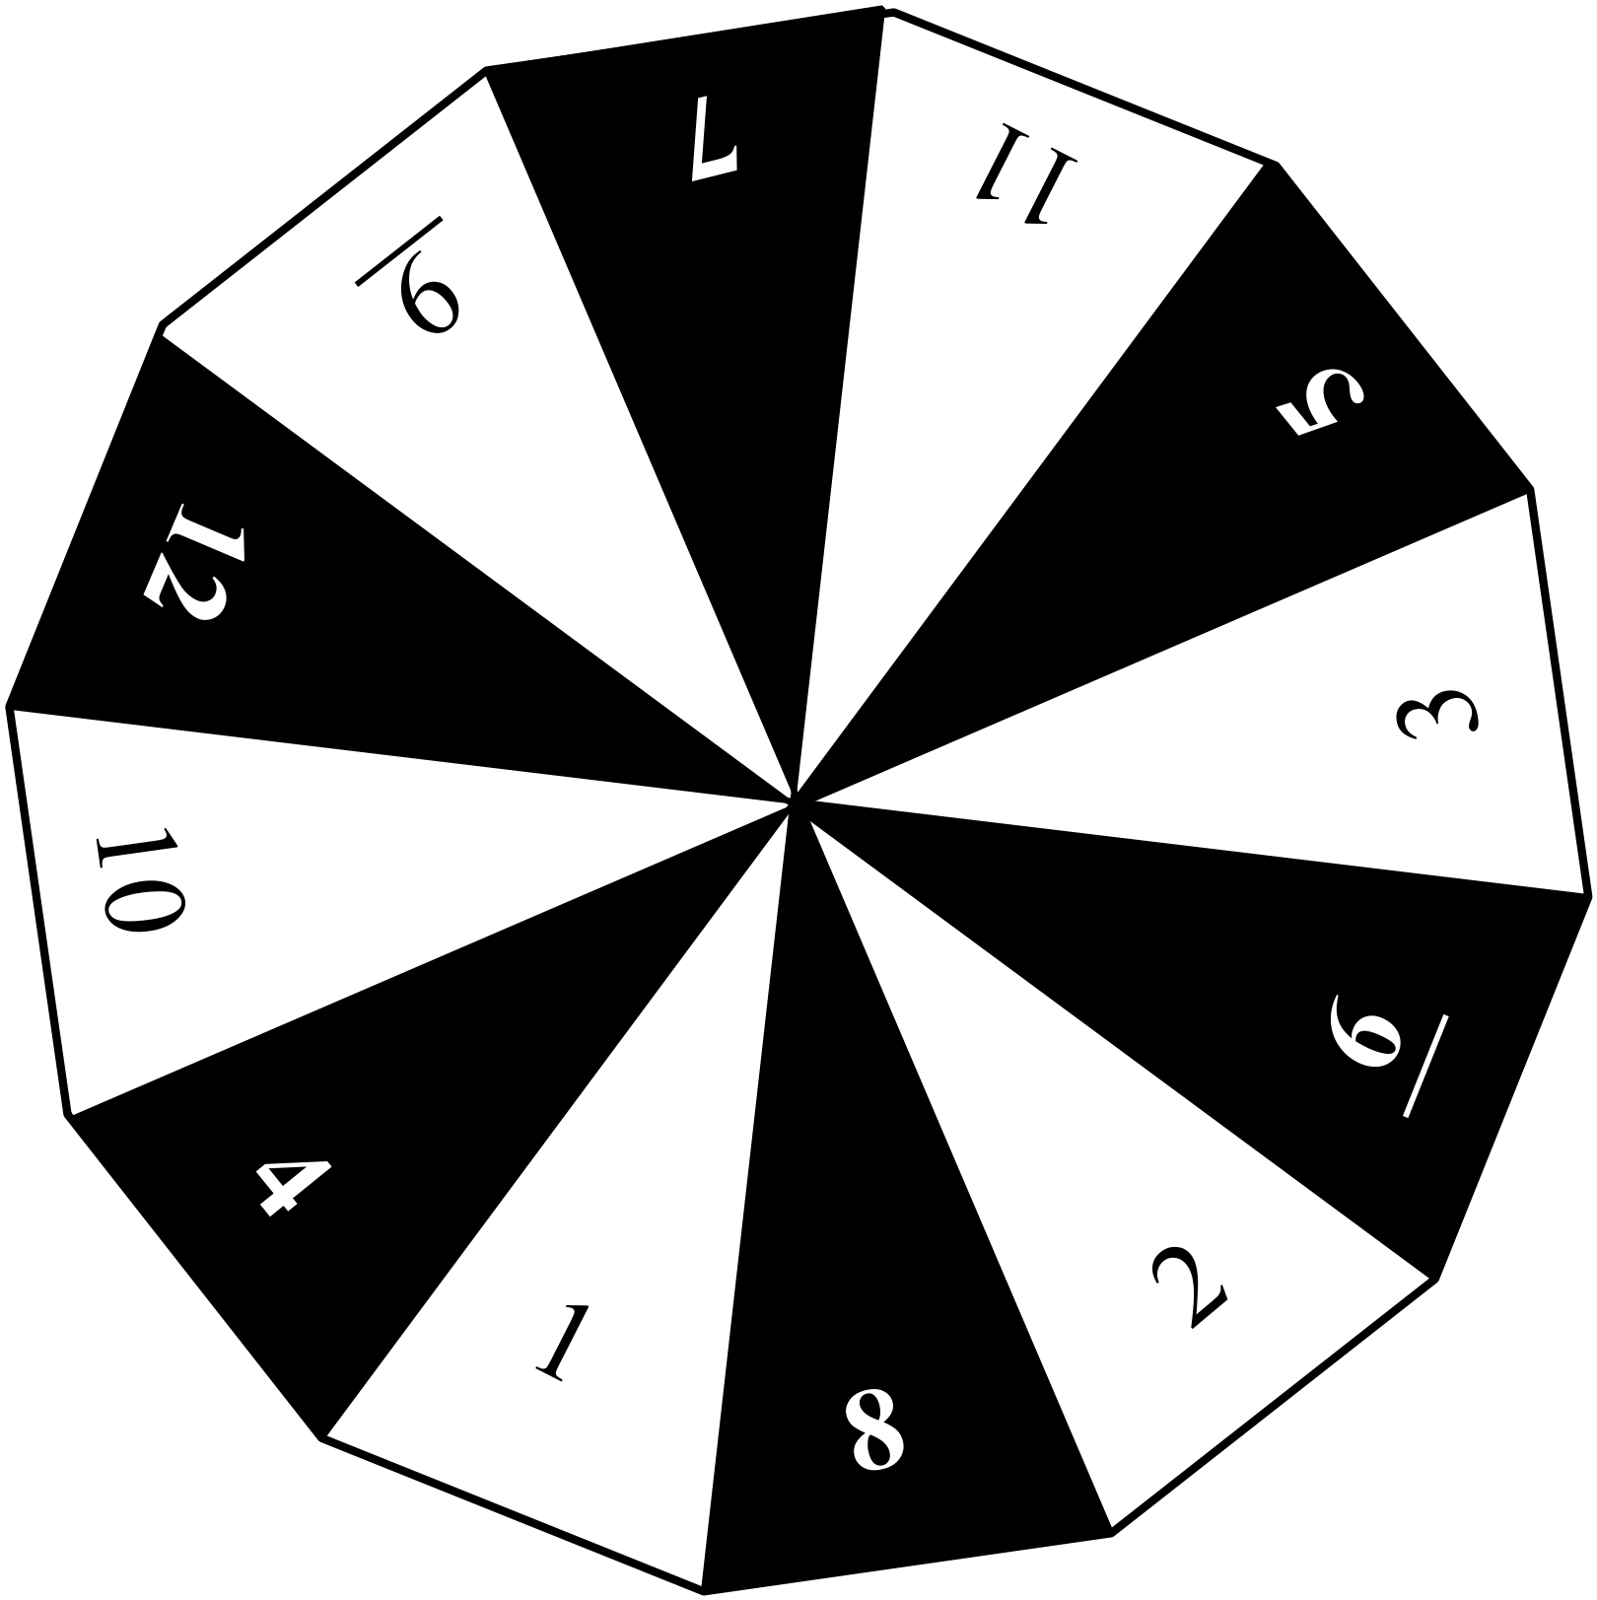A spinner for a game has 12 divisions which are coloured white and black and numbered 1 to 12 as shown.
 | (a) What is the probability of spinning an even number that is on a black segment?  ………………………………………………………………………………………………  ……………………………………………………………………………………………… | 1
 | (c) What is the probability of spinning a number less than 5 or a number on a black segment or both?  ………………………………………………………………………………………………  ……………………………………………………………………………………………… | 1
81. | Fifty-five players took part in a golf tournament. Their scores on two rounds of 18 holes are shown on the back to back histogram below.  Scores on Two Rounds of the Birdsville Open Golf Tournament
  Round 1 ( 1st 18 holes) |  |  |  |  |  |  |  |  |  |  |  |  | Score | Round 2 (2nd 18 holes)
   |  |  |  |  |  |  |  |  |  |  |  |  | 71
   |  |  |  |  |  |  |  |  |  |  |  |  | 70
   |  |  |  |  |  |  |  |  |  |  |  |  | 69
   |  |  |  |  |  |  |  |  |  |  |  |  | 68
   |  |  |  |  |  |  |  |  |  |  |  |  | 67
   |  |  |  |  |  |  |  |  |  |  |  |  | 66
   |  |  |  |  |  |  |  |  |  |  |  |  | 65
   |  |  |  |  |  |  |  |  |  |  |  |  | 64
   |  |  |  |  |  |  |  |  |  |  |  |  | 63
   |  |  |  |  |  |  |  |  |  |  |  |  | 62
   |  |  |  |  |  |  |  |  |  |  |  |  | 61
  12 |  | 10 |  | 8 |  | 6 |  | 4 |  | 2 |  |  |  |  | 2 |  | 4 |  | 6 |  | 8 |  | 10 |  | 12
 | (a) What was the mean score on Round 1 of the tournament?  ………………………………………………………………………………………………  ……………………………………………………………………………………………… | 1
 | (b) Without further calculation, compare the shape of the distribution for Round 1 with that for Round 2.  Include reference to the skew of the two distributions and to the comparative values of the mean and/or median for each round.  ………………………………………………………………………………………………  ……………………………………………………………………………………………… | 2
82. | (a) Express 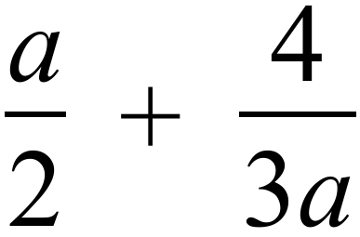 as a single algebraic fraction in simplest form.  ………………………………………………………………………………………………  ………………………………………………………………………………………………  ……………………………………………………………………………………………… | 2
 | (b) Solve 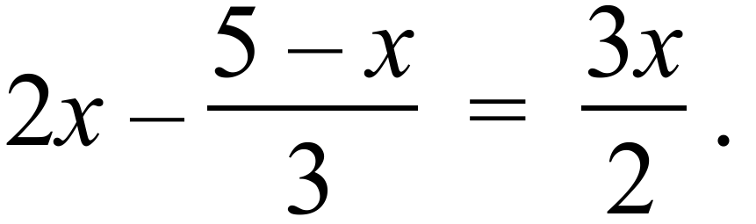  ………………………………………………………………………………………………  ………………………………………………………………………………………………  ………………………………………………………………………………………………  ……………………………………………………………………………………………… | 2
83. | The points A(-4, -2), B (0, 6), C(7, 4) and D (4, -2) are the vertices of a quadrilateral.  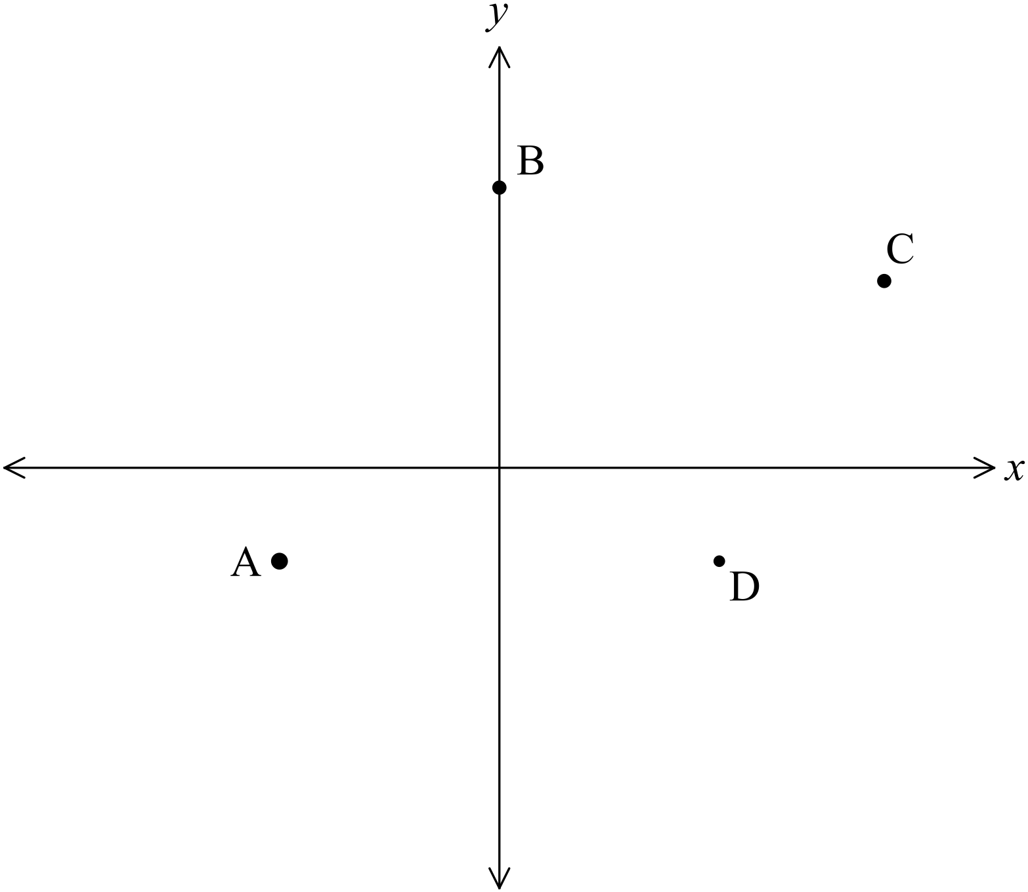 | 3
Use the gradients of the sides to show that the quadrilateral is a trapezium.

……………………………………………………………………………………………….

……………………………………………………………………………………………….

……………………………………………………………………………………………….

……………………………………………………………………………………………….

High School
Half - Yearly Exam
Mathematics Course
Multiple Choice Section Answer Sheet

Name ________________________________ Teacher ________________________
Completely fill the response oval representing the most correct answer.

26. A B C D
27. A B C D
28. A B C D
29. A B C D
30. A B C D
31. A B C D
32. A B C D
33. A B C D
34. A B C D
35. A B C D
36. A B C D
37. A B C D
38. A B C D
39. A B C D
40. A B C D
41. A B C D
42. A B C D
43. A B C D
44. A B C D
45. A B C D
46. A B C D
47. A B C D
48. A B C D
49. A B C D
50. A B C D

51. A B C D
52. A B C D
53. A B C D
54. A B C D
55. A B C D
56. A B C D
57. A B C D
58. A B C D
59. A B C D
60. A B C D
61. A B C D
62. A B C D
63. A B C D
64. A B C D
65. A B C D
66. A B C D
67. A B C D
68. A B C D
69. A B C D
70. A B C D
71. A B C D
72. A B C D
73. A B C D
74. A B C D
75. A B C D

